January 8, 2024 Program
9:30 a.m.

Nuno Felting and More!
Martha Lumia, Presenter

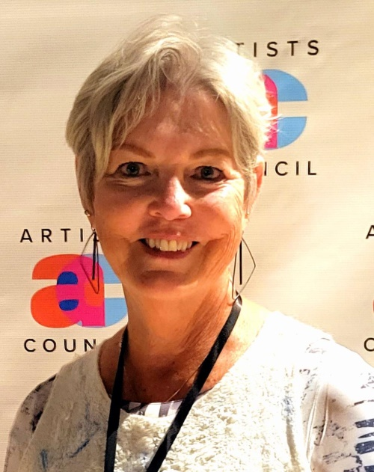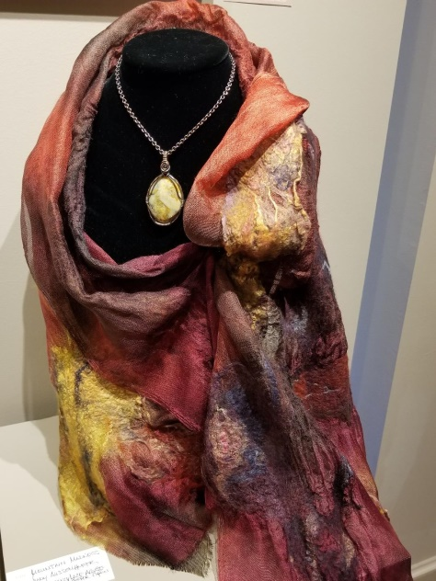

Martha’s journey into Nuno Felting began in 2009. She fell in love with the beautifully textured, lightweight, drapeable fabric that developed when a lightweight silk or cotton was overlaid with wool fibers, and then agitated and manipulated with soap and water.

Her presentation will include a brief history of felting as well as a discussion and comparison of Nuno Felting and wet felting. She will bring samples of nuno and wet felted wearables, 3D art using wool and paper and other handcrafted pieces.

This program will be broadcast in a Zoom format, but come in person for a truly visual and tactile experience.

Martha became interested in ‘fiber art’ around 2009, but in reality, she always had an interest in fabric and fiber and was a maker and creator. Her fiber mediums included sewing, quilting, knitting, crochet, and mixed media.

She also enjoyed the textural qualities of bread making when the dough changed during the kneading process. So in the process of wet felting she was wooed by the feel of the raw wool, silk and other natural fibers as they morphed into a work of art. Adding color to the mix takes felting up another notch.

Martha has taken many felting classes and participated in numerous workshops. She continues to discover new techniques taking her felting towards 3D sculpture and fiber display art.

Check out MJL Fiber Arts: https://www.pinterest.com/marthalumia/mjl-fiber-arts/

Meeting time: 9:30 – 11:30 a.m.
Meeting location: Redlands Senior Center
Lugonia room
111 W. Lugonia Ave.
Redlands, CA 92374

